How is Nuclear Energy Produced?
By Eoghan Hayes
Sixth Class
Nuclear Energy is a clean, reliable source of energy.It has many advantages over burning fossil fuel as it does not leave out fumes. Nuclear Energy is produced in nuclear power plants that can be found all over the world but not in Ireland.

To know how nuclear energy is produced we must understand nuclear fission. Nuclear fission is another name for a nuclear reaction which occurs when the nucleus (see diagram 1)of a radioactive element such as uranium 235 or plutonium 239 is split by another neutron. This releases a large amount of energy along with three more neutrons which then go onto split other nuclei, this is called a chain reaction (see diagram 2).

So how does this produce energy? Inside the reactor there are many nuclei circulating around so when they insert the uranium rods a reaction starts almost immediately, but they must control the level of fission and do this by inserting what are known as control rods. These control rods are made out of a special material that is able to absorb escaping neutrons. They can pull these rods in and of the reactor depending on the levels of escaping neutrons. Once the reaction has started the reactor gets very hot so by placing water around the reactors they can create steam which then goes onto powering a turbine hence creating electricity.

Although nuclear energy is frowned upon by many we are quickly running out of fuels such as gas and coal and this type of energy may be the future.

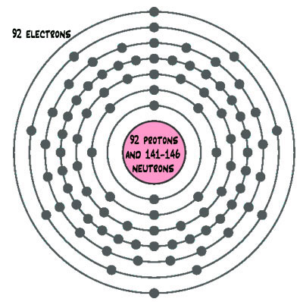
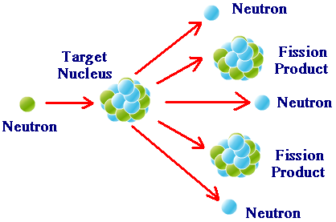
Diagram 1 Diagram 2

