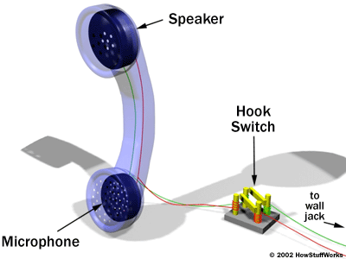
HOW TELEPHONES WORK

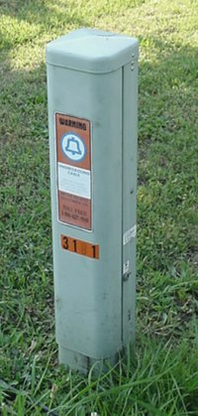
Telephones are a thing most of us use in our everyday life.They are simple to use, If you want to talk to someone, all you have to do is pick up the phone and dial a few digits. You are instantly connected to that person, and you can have a two-way conversation.When a person speaks into a telephone, the sound waves created by their voice enter the mouthpiece. An electric current carries the sound to the telephone of the person they are talking to. The telephone network starts in your house. A pair of wires runs from a box outside your home to a box (often called an entrance bridge) at your house. From there, the pair of wires is connected to each phone jack in your house. From this box, the wires lead to various places, such as telephone wires, where a lot of people think they mostly go. But if you want to speak to people abroad there are telephone wires under the sea.
References to: Google search engine. The book “tell me how” and www.howstuffworks.com

