Science week 2013
As it was science week our class did a science exhibition for the rest of the school. Amy,Sadie and Heather decided to do an experiment together, to look at how acid affects different objects. This is what they did .……..
Amy did an experiment on teeth in coke. The teeth rotted and turned brown because acid and food colouring in coke changed it. 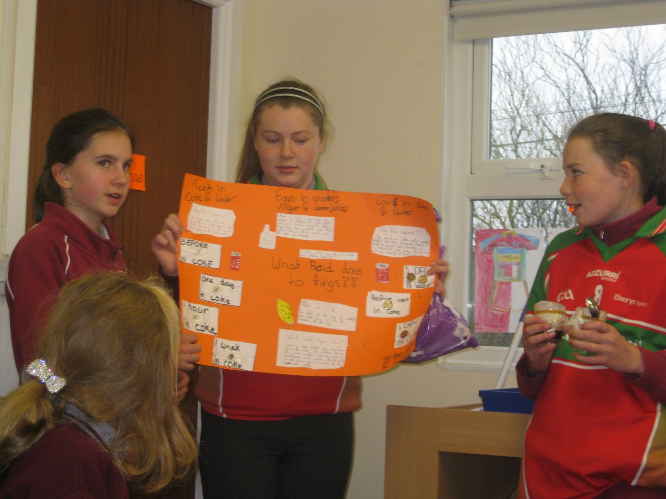
Sadie and Heather did an experiment on eggs. Heather put a hard boiled egg in lemon juice. The acid in the juice ate away at the shell and made the egg bouncy.Sadie also put an egg in vinegar and the same affect happened as Heathers experiment.
They all did an experiment together also. Amy got coke and Heather and Sadie got coins. Heather put a coin in water and Sadie put a coin in coke. The acid in coke eats away and the rust and dirt and leaves a shiny coat. Overall they learned what acid does to objects.
Sadie, Heather and Amy all hope the classes learnt something. Hopefully they all remember to brush their teeth !!!!!! They would hope this recent success with science week will carry on through out the coming years.

