SCIENCE WEEK 2013
We were so excited about doing our cool science experiments and we could see the other classes were bursting with excitement too. The day couldn’t have been better then it was already even though we felt nervous because we were not sure if the children enjoyed it as much as us, but at break time the gossip broke out about us.
First we did the M’n’M‘s experiment…You can do these experiments at home!
First we put the M’n’M’S in water and let them sit for 3-4 minutes. They sank and lost their colour and there m’s peeled off and came to the surface of the water. Our second experiment was food colouring in milk we put the milk in a plate. When we put the food colouring in it didn’t mix but when we put soap on our finger and tipped the milk it spread and if you get a straw and blow you can make shapes in the milk.
They were mesmerised by the talent of the science experiments we were delighted with the results. We hoped that the kids went home and tried the experiments. It was a fun experiment so even if they didn’t like it we enjoyed it. ;)

Milk and food colouring 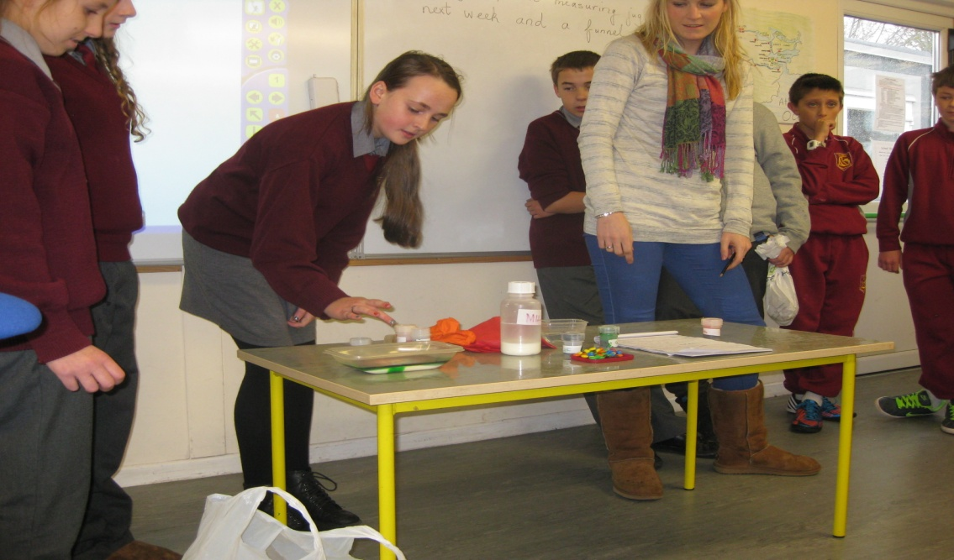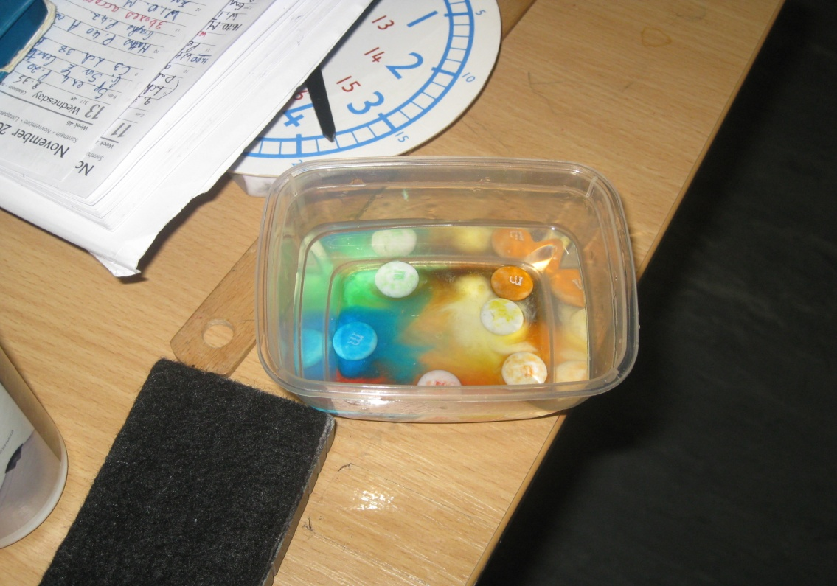
And the M&M one.

