Science Fair 2013
It was a normal school day for 6th class of Shanbally N.S when they got info on Shanbally’s first science fair.
First of all we chose our groups Alex, Seán, Kevin and Carl got together. Straight away Seán thought of doing an egg into a bottle experiment. We all thought that was a great idea. What you need is a glass milk bottle, a hard boiled egg, matches & a piece of dry newspaper. Remember you should always be safe around matches and should have a grown-up around you.
First you light the piece of newspaper on fire and let it burn for around 4-5 seconds and put it in. Then quickly put the peeled hard boiled egg on top of the neck of the bottle. Now watch as the egg gets sucked in, this happens because when you put in the fire the air inside becomes extremely hot, also fire needs oxygen to stay burning so when you put the egg on the bottle it extinguishes immediately. Now the egg clogs up the only way of the hot air trying to cool down so to get colder the air has to suck in the egg to get out of the closed bottle. Then we thought that was not enough so Alex added. “I saw an interesting video on youtube about a coke can standing exactly diagonally on its side”. This happens because when you put 100 mils of water into a 33cl coke can it stands. Why you may ask? The dynamics of the water makes it stay.
Now we also needed another experiment. This experiment involved gummy bears. Just put the gummy bears into water and over time the gummy bear absorbs the water. It is a quick but interesting experiment.
We had a great time watching the other classes enjoy us. We also hope the class will do the same next year but not as good as us. We had a great week and hope to do it again!

By Alex, Carl, Kevin & Seán.

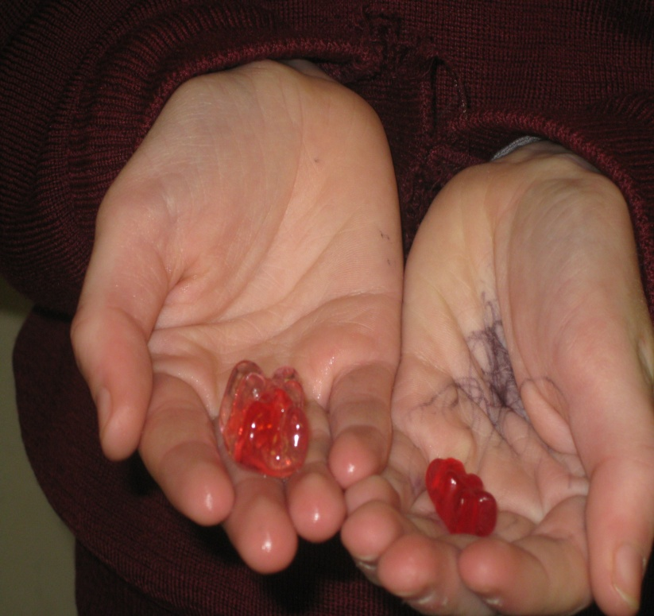

The two gummy bears- before and after
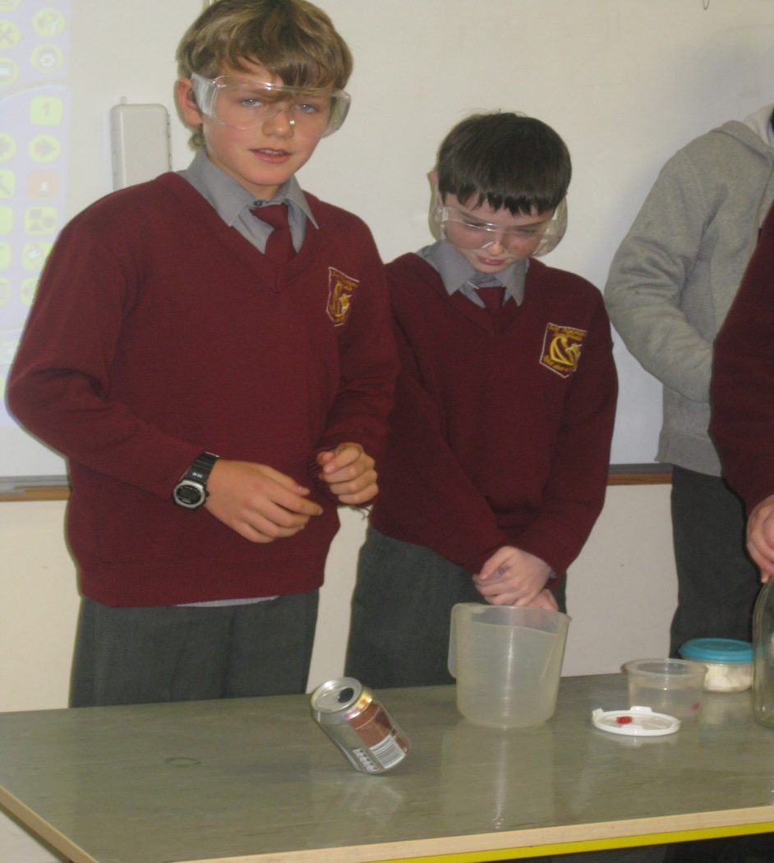
!!!Amazing!!!
!!!RIGHT!!!

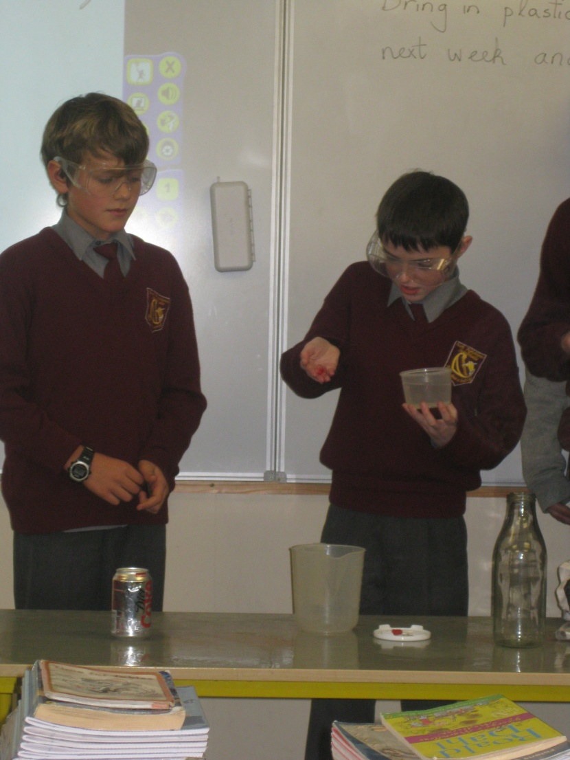
The gummy bear experiment
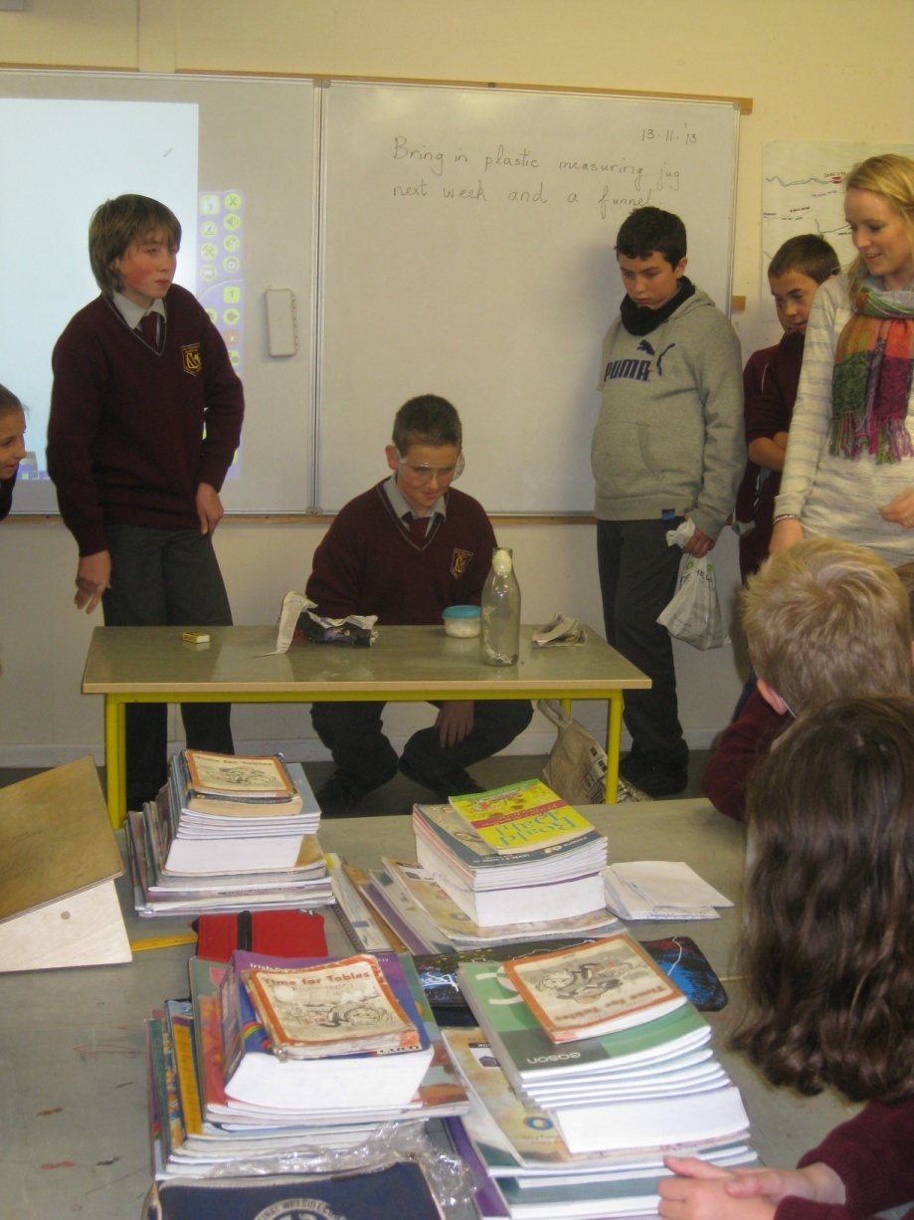
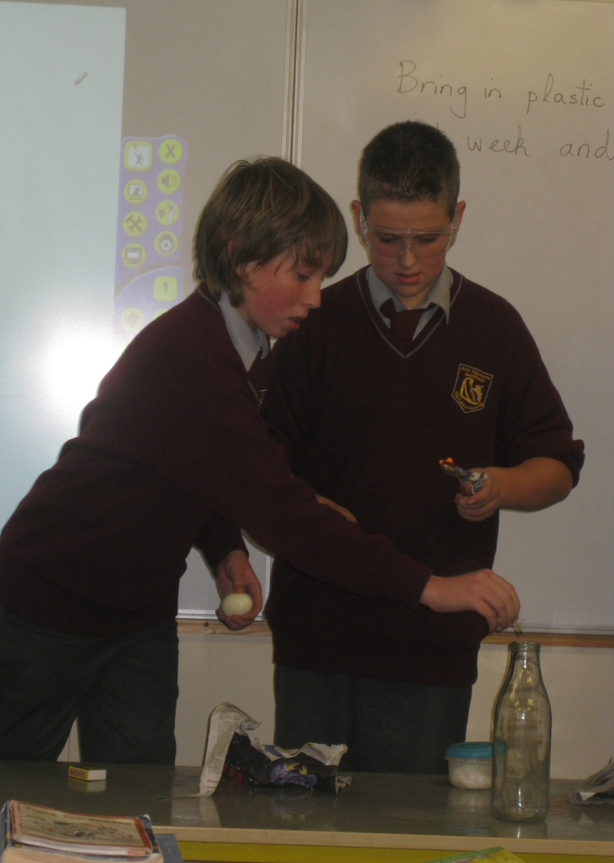Egg Waiting with
in Anticipation
the bottle
experiment

