Our Science Exhibition in Shanbally 2013
It was science week and all of our school was hyped up to do some science. All of the classes researched some science experiments. All of the younger classes stuck to the simple experiments while the older classes did some more advanced experiments. On the 14th of November 6th class held a science exhibition. Two classes came in at a time, first 1st and 2nd class came in, and then 4th and 5th. We also visited junior infants and senior infants and showed them some science experiments. 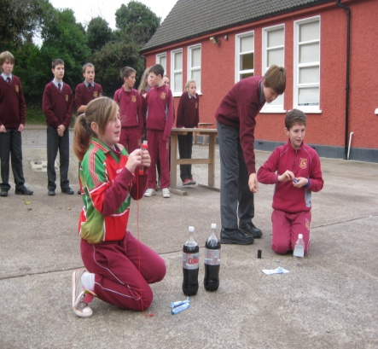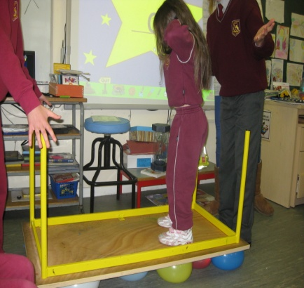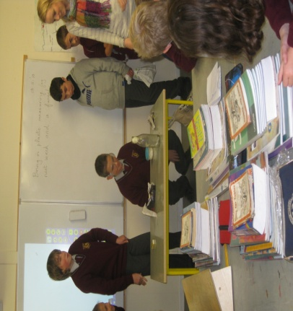
A few groups were made and each group had an experiment to do. Each group was called one by one to show their science experiment and explain how it works. Some experiments were the table on balloons, the egg in the bottle and the coke and mentos which was held outside. All of the classes really enjoyed science week and they all learnt a lot about science. I think the day was very successful and lots of fun!
By Christopher Sisk

